**TASK 4:**

**Answers**

***1) Program – Checking and comparing sum of numbers***

**package** java_Tasks;

**import** java.util.Scanner;

**public** **class** Task1_IntroductionToJava {

**public** **static** **void** main(String[] args)

{

//Question 1 :

System.***out***.println("Enter the numbers");

Scanner sa = **new** Scanner(System.***in***);

**int** a = sa.nextInt();

Scanner sb = **new** Scanner(System.***in***);

**int** b = sb.nextInt();

Scanner sc = **new** Scanner(System.***in***);

**int** c = sc.nextInt();

Scanner sd = **new** Scanner(System.***in***);

**int** d = sd.nextInt();

System.***out***.println(a + " " + b + " "+ c+ " "+d);

**int** e = a+b;

**int** f = c+d;

**if** (e>f)

{

System.***out***.println("The sum of a and b is greater than the sum of c and d");

}

**else**

{

System.***out***.println("a and b not greater than c and d");

}

sa.close();

sb.close();

sc.close();

sd.close();

}

}

***Output:***

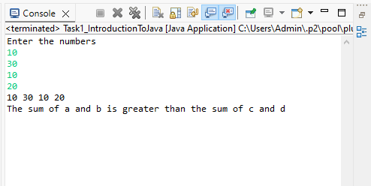

***2) Program – check for Even_number:***

**package** java_Tasks;

**import** java.util.Scanner;

**public** **class** Task1_CheckEvenNumber {

**public** **static** **void** main(String[] args)

{

// **TODO** Auto-generated method stub

System.***out***.println("Enter a number");

Scanner sa = **new** Scanner(System.***in***);

**int** i = sa.nextInt();

**if** (i%2==0)

{

System.***out***.println(i + " is an even number");

}

**else**

{

System.***out***.println(i + " is an odd number");

}

sa.close();

}

}

**Output:**

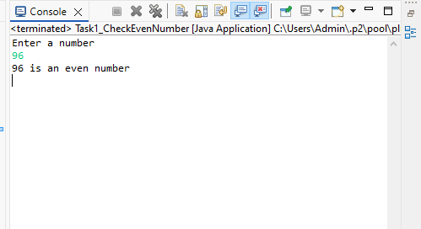

***3) Program – Printing alphabets A-Z:***

**package** java_Tasks;

**public** **class** Task1_PrintA_to_Z {

**public** **static** **void** main(String[] args)

{

// **TODO** Auto-generated method stub

System.***out***.println("Printing characters from A to Z");

**for** (**char** c = 'A'; c<= 'Z'; c++)

{

System.***out***.println(c);

}

}

}

***Output:***

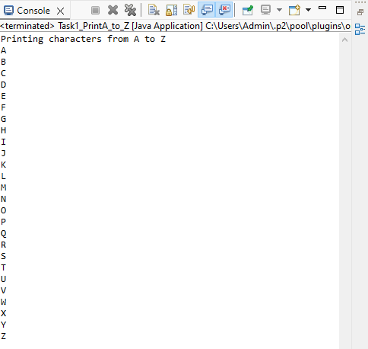

4) Program – Swapping 2 Numbers:

**package** java_Tasks;

**import** java.util.Scanner;

**public** **class** Task1_Swapping {

**public** **static** **void** main(String[] args)

{

// **TODO** Auto-generated method stub

System.***out***.println("Enter 2 numbers");

Scanner sa = **new** Scanner(System.***in***);

**int** a = sa.nextInt();

Scanner sb = **new** Scanner(System.***in***);

**int** b = sb.nextInt();

**int** temp;

System.***out***.println("Numbers before swapping" +" "+ a + " "+ b);

temp = a;

a=b;

b=temp;

System.***out***.println("Numbers after swapping" +" "+ a + " "+ b);

sa.close();

sb.close();

}

}

Output:

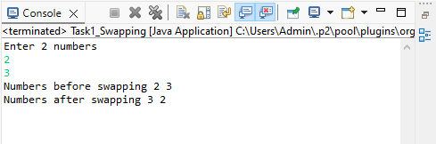

5) Program – Check Prime number:

**package** java_Tasks;

**import** java.util.Scanner;

**public** **class** Task1_PrimeNumber {

**public** **static** **void** main(String[] args)

{

// **TODO** Auto-generated method stub

System.***out***.println("Enter a number");

Scanner sa = **new** Scanner(System.***in***);

**int** a = sa.nextInt();

**int** count = 0;

**for** (**int** i=1; i<=a; i++)

{

**if**(a%i==0)

{

count++;

}

}

**if**(count==2)

{

System.***out***.println("Number is a prime number");

}

**else**

{

System.***out***.println("Number is not a prime number");

}

sa.close();

}

}

***Output:***

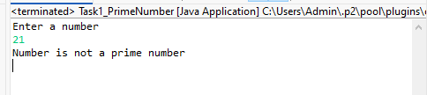

***6) program – Factorial of given number:***

**package** java_Tasks;

**import** java.util.Scanner;

**public** **class** Task1_Factorial {

**public** **static** **void** main(String[] args) {

// **TODO** Auto-generated method stub

System.***out***.print("Enter the number :");

Scanner s = **new** Scanner(System.***in***);

**int** num = s.nextInt();

**long** f = 1;

**if** (num < 0) {

System.***out***.println("Cannot find Factorial for Negative numbers");

}

**else**

{

**for** (**int** i = 1; i <= num; i++)

{

f = f*i;

}

System.***out***.println("Factorial of " + num + " is: " + f);

}

s.close();

}

}

***Output:***

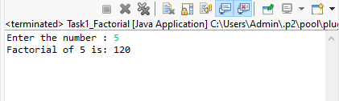

***7) Program – Find length of string:***

**package** java_Tasks;

**import** java.util.Scanner;

**public** **class** Task1_LengthOfStrng {

**public** **static** **void** main(String[] args)

{

System.***out***.println("Enter the string");

Scanner sc=**new** Scanner (System.***in***);

String Str=sc.nextLine();

System.***out***.println("Enter the string");

System.***out***.println(Str.length());

}

}

***Output:***

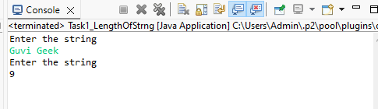

***8) Program: Print “Welcome to Guvi” 10 times:***

**package** java_Tasks;

**import** java.util.Scanner;

**public** **class** Task1_WelcomeToGuvi {

**public** **static** **void** main(String[] args)

{

// **TODO** Auto-generated method stub

System.***out***.println("Enter the string");

Scanner sc=**new** Scanner(System.***in***);

String Str = sc.nextLine();

**for** (**int** i=0; i<10; i++)

{

System.***out***.println(Str);

}

}

}

***Output:***

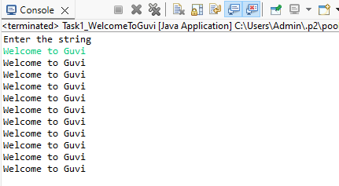

***9) Program – Check person is a senior citizen or not:***

**package** java_Tasks;

**import** java.util.Scanner;

**public** **class** Task1_Check_SeniorCitizen_OR_not {

**public** **static** **void** main(String[] args)

{

// **TODO** Auto-generated method stub

System.***out***.println("Enter the age of a person");

Scanner sc = **new** Scanner(System.***in***);

**int** age = sc.nextInt();

**if** (age < 60)

{

System.***out***.println("Person is not a senior citizen");

}

**else**

{

System.***out***.println("Person is a senior citizen");

}

sc.close();

}

}

***Output:***

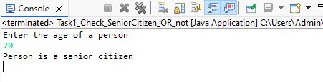

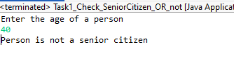

***10) Program – Check number of digits in Integer***

**package** java_Tasks;

**import** java.util.Scanner;

**public** **class** Task1_CountNumberOfDigits {

**public** **static** **void** main(String[] args)

{

// **TODO** Auto-generated method stub

**int** c = 0;

System.***out***.println("Enter the number");

Scanner sc = **new** Scanner(System.***in***);

**int** a = sc.nextInt();

**while** (a != 0) {

// num = num/10

a = a/10;

++c;

}

System.***out***.println("The Number of digits " + c);

sc.close();

}

}

***Output:***

